ESS 421

NAME __________________

Laboratory No. 3: Atmospheric Compensation using MODTRAN

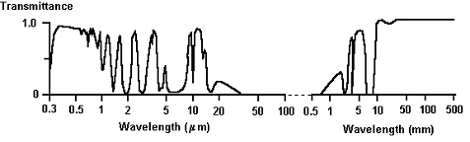

QUESTION 1:
U.S. model Tropical model
a) What is the transmissivity at about 1.06 µm? ___________ __________
b) What is the transmissivity at about 0.94 µm? ___________ ___________
c) What is the transmissivity at about 1.39 µm? ___________ ___________

QUESTION 2:
How do your values for transmissivity at 1.06 µm, 0.94 µm, and 1.39 µm for the Tropical model compare with what you observed for the standard atmosphere? What is the most likely difference in the atmosphere that is responsible for the observed differences in transmissivity? (HINT: Why is there a change in the depth of the water band at 0.94 µm and not at 1.39µm?) Use the graph above and your brain to help.

PART II: TIR transmittance and path radiance for the standard atmosphere
QUESTION 3:
60 km 6 km
a) What is the transmittance at ~9.0 µm? ___________ ___________
b) What is the transmittance at ~9.5 µm? ___________ ___________

c) Describe the difference between the transmittance at 60 km and 6 km. Has the transmittance changed? What atmospheric property could explain your observations?

QUESTION 4: (remember to specify the units you are using)

Top of envelope Base of envelope
a) What is the Path Radiance at ~9.0 µm? ____________ _____________
b) What is the Path Radiance at ~9.5 µm? ____________ _____________

PART III: Atmospheric Scattering:
Question 5:
- Draw a rough estimate of how you would expect atmospheric scattering to behave as a function of wavelength in the VNIR:

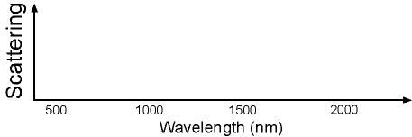

Question 6:
Answer the following:
- What could be a possible source for the ‘haze’ in the right part of the top image?

- Why is there less ‘haze’ in the left part of the top image?

- Why is there less haze in the right part of the bottom image than in the right part of the top image?

